
FLAT GU10 5.5W 830
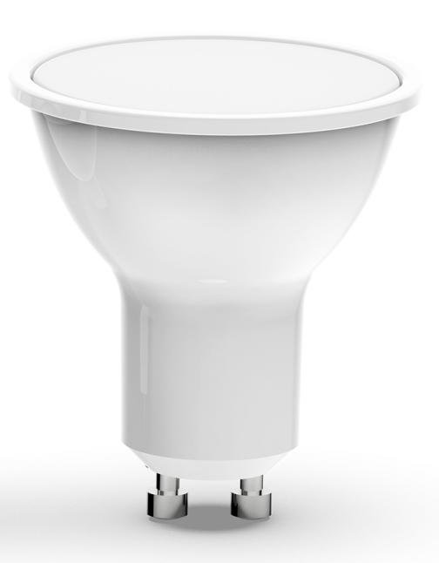 | Compatible with GU10 base fixtures lamp, convenient and quick to use. Featuring a PC housing with optimized heat dissipation design for stable and durable performance. Equipped with high-brightness LED chips, it delivers 440 lumens at low power consumption of 5.5W, matching the brightness of traditional 38W halogen bulbs. Boasting a color rendering index of Ra≥80 for true color reproduction.
 | CHARACTERISTIC
• Modern and robust design. Supply voltage AC165-240V.
• Compatible with GU10 base fixtures lamp.
• Operating environment temperature: -25°C~+40°C.

 | APPLICATION
 | All fixtures using the GU10 base, such as spotlights, downlights, and track lights,etc.
 |  |  |  |  |  |  |  |  |  |  |  |  |  |  | 
OPTICS DATA |  | PHYSICAL DATA |  | ELECTIRCAL DATA
Colour Temperature | 3000 K (NW) | Finish | White | Input Power | 5.5W
Flux Lumen | 440 lm | Grade of Protection IP | IP20 | Operating Voltage | 165-240V 50/60 Hz
Beam Angle | 38° | Dimensions (LxWxH) | 46*55mm | Power Factor | >0.5
Type of Distribution | Non-directional | Type of Mounting | Suspended/Surface/Recessed
Colour Rendering Index (CRI) | >80 | Housing | PC
Lifetime | 25000 h L70B50 | Type of Driver | /
Efficiency | 80 lm/W | Operation Temperature Ta | -25°C~+40°C
DIMENSIONS | PHOTOMETRICS
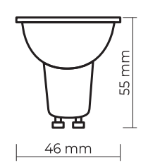 | 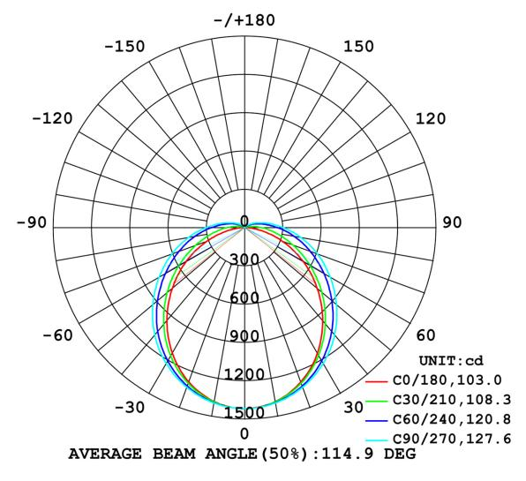
The characteristics of the products may be  modified without prior notice depending on the  evolution of LED technology. 01/22 | Ecological Product: Allows you to save  energy compared to traditional products.  Mercury free.

